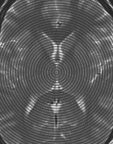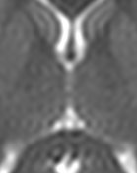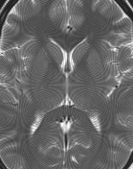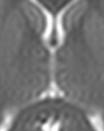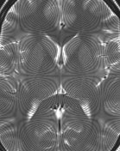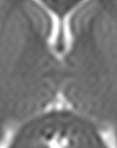

MRI with noise

MRI with noise

MRI with noise

**Figure 7.** Removal of the noise by the use of the adaptive Sinc-Zoom technique. From left to right the figure shows the MRI with noise, and the removal of the noise while zooming using S = 4 sfu and the zoom factor $z_{f}=0.1$. These results cannot be obtained with the non-adaptive Sinc-Zoom. Hence, as far as regards this aspect, the Adaptive-Zoom technique remains superior.